THE INFORMER JANUARY
Spotsylvania Sunday School Union Newsletter Vol. 2023 #1

President’s Pen

Hello, my Christian Sisters and Brothers,

Today I was reminded of the old saying about how some people see a cup half empty while others see it as half full. This reminds me of the way we look at life. Our viewpoint reflects our attitude which reflects our opinion concerning our future. You see most Christians are overjoyed because God has at least put something in their cup so they are blessed. It’s amazing how a rich man can be miserable because he always wants more of the earth’s riches while a poor man can be overcome with joy because he knows from where his blessings originate. This alludes to the passage in Matthew 6:21 “Where a man’s treasurer is, there also is his heart.” We should be careful about the things we treasure and always give thanks to God for even the simplest pleasures in our lives. We should challenge our children to not only continue their religious education but also encourage them to seek secular opportunities as well. Let them know that they will face challenges in their lives but through God these challenges can become opportunities for advancements depending on if they see the glass half empty or half full. Most of the time God won’t fill our cup to the brim because we will always need room for improvement. Improvement in our worship, our Christian attitudes, moral values, our communications with God (prayer), the way we handle adversities, communicate with our families and friends, the way we help others, and I could go on and on. I, however, think you get the idea of why God doesn’t fill up a cup that needs to develop what is necessary to grow into what God knows they can become if they follow his teachings and guidance.

The Spotsylvania Sunday School Union (SSSU) is one of the many resources that God has provided for our children to develop into the strong people of God by taking advantage of the scholarships provided every year to those that know they need to continue to ask God to keep something in their cups. Through prayer and supplication, not by boastful self-indulgence filled with vain pride. The SSSU encourages our youth to take advantage of all available educational opportunities and to be bold Christians through God as they acquire that which they so rightfully deserve. We encourage our youth to be proud of their rich, diverse and sometimes difficult history and never forget where their people came from. Please don’t try to live in the past, just understand and embrace it to gather strength, wisdom and self-fortitude by further understanding through the word of God.

May we all be blessed in this New Year and continue to grow through God’s word.

Thomas Roberson, President SSSU

SSSU 2023 General Meetings Schedule

All meetings will be in person and virtual

Jan. 29 - Branch Fork
Apr. 30 – First New Hope
July 30 - Little Mine Road
Oct. 29 - Mt Olive

MEMBERSHIP UPDATE

Are you a member of the Union? Have you renewed your Union membership this year? If not, now is the time to do so! The Union’s dues will remain the same for this year of 2023.
Annual dues - $12.00 per year from Jan. to Dec.
Lifetime membership - $125.00
Union Church representations dues - $300.00
All donations are gratefully appreciated.

For a membership application visit our website at:
www.spotsylvaniasundayschoolunion.com or check with your Trustee assigned to the Union for a copy.

Checks should be made payable to:
SSSU
Attn: Treasurer
PO Box 78
Thornburg, VA 22565

HOW THE UNION IS FUNDED

The Union is funded through registration fees of its member churches, individual memberships, rental fees from the Spotsylvania Sunday School Union Parksite facility, gifts, donations and grants. The Union is a 501 (C) (3) status approved by the Internal Revenue Code and is organized for charitable, educational and religious purposes.

COMMUNITY ANNOUNCEMENTS

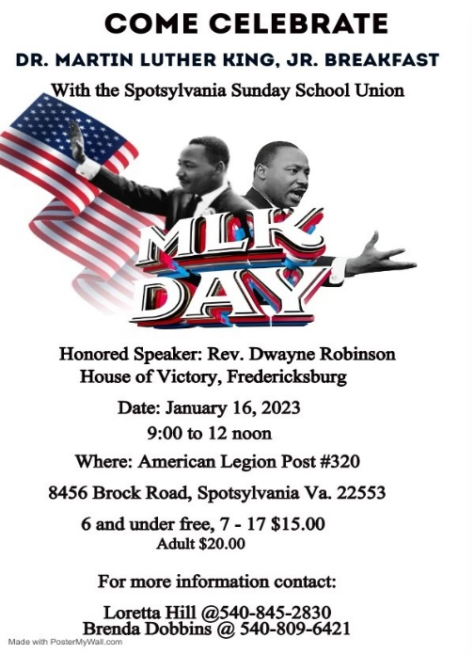

SSSU Black History Program

Date: February 18, 2023
Where: John J Wright Educational and Cultural Center Auditorium
Time: 11 am – 1 pm
Honored Guest: Sister Cleo Coleman performing as Harriet Tubman.
Join us for a free Historical Story live on stage!!

Delicious Refreshments will be served and waiting for everyone immediately after the performance at the Parksite. This will give you a chance to visit our new kitchenette inside the Ross Memorial Building that’s now completed!
Thank you in advance for your support of this great Union and its programs!!

NAACP NEWS
The Spotsylvania Branch of NAACP meets on the first Thursday of each month by zoom. If you’re a member, you’ll be notified by President Petway before each meeting.

HAPPY ANNIVERSARY!

Elder Mozett Petway, Pastor of God’s House of Blessings will be celebrating his 8th Anniversary as Pastor on January 22, 2023.

SSSU PARKSITE UPDATE

The Union’s Executive Board and Trustees worked hard and diligently together in 2022 to make the Parksite more accessible and comfortable for the Union’s member churches, members and the surrounding communities.
These are the updates completed on the Parksite grounds and inside the Ross Memorial Building in 2022:
- The entrance hedges were cut back and the leaves removed
- A portion of the entrance driveway was filled with gravel
- New signs were added at the entrance
- The kitchenette was completed with new cabinets, a sink and a stove.

With all the maintenance and installations done inside the building last year, the rental fee has been increased to $175.00 per rental with a $50.00 returnable fee if the building is cleaned properly inside and outside after being used. For rental applications, go to our website:
www.spotsylvaniasundayschoolunion.com

CHURCH NEWS AND COMMUNITY EVENTS

Zion Hill
Another Year of God's Grace and
Mercy. As we close out the year of 2022 Zion Hill continued:
• To help those at Thanksgiving with a meal.
• Assisted those in need with temporary housing.
• Prepared Toys for Tots for over 275
children, and the Donations we received were a Blessing. It allowed us buy more
toys to fulfill the orders
.• We visited Carriage Hill Nursing Home on December 26, bringing lots of gifts
for the residents and a spoken word by Minister Alonzo Woolfolk and Minister Keith Strother.
• Leadership would like to thank the members, family and friends for their
continued and faithful support of the church and each other.
• We look forward to 2023, Zion Hill
will encapsulate, envision and endeavor the new Vision and Projects that God has for Zion Hill ensuing years.

Back to School Event
Save the date: July 15, 2023 and rain date July 22, 2023. This event will start at 12 noon. If anyone would like to volunteer to help, contact Trustee Brenda Dobbins at (540) 809-6421.

CHURCH NEWS AND COMMUNITY EVENTS

Second New Hope

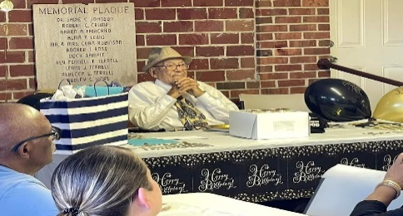
Mr. Samuel Fairchild
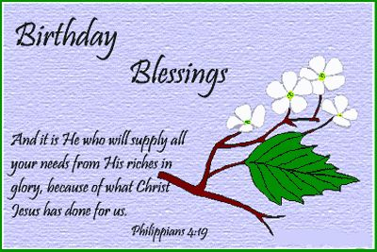

October 15, Mr. Samuel Fairchild arrived for a surprised
celebration of his 100th birthday held at the Spotsylvania Sunday
School Union Parksite. This outstanding occasion was hosted
by his daughter Brenda Morris and family.

Pastor Charles Hilliard celebrated his birthday
on November 7th!
Chairman, Deacon Dennis Samuel celebrated his birthday on November 19th!

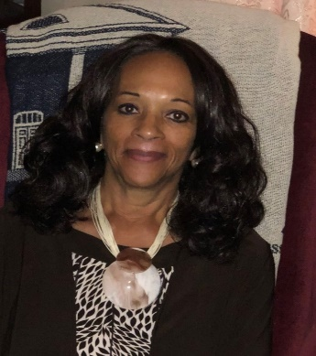

Happy Birthday Minister Amelda Fay Jones,
better known to all of us as “Fay.” She celebrated her
Birthday on December 9th!

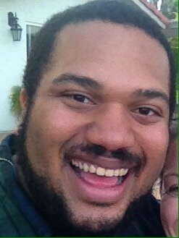

Bro. Rodney Jones, Jr. turned 36 on
December 18th and is thankful to God
for another year of life and grace.

CHURCH NEWS AND COMMUNITY EVENTS

Second New Hope
The 2022 Alzheimer's Association® Walk to End Alzheimer's® was a great success!
On October 8th the Alzheimer's Association planned a hybrid community walk approach for the 2022 Walk season held at the Old Mill Park, 2201 Caroline Street, Fredericksburg. Ministers Rodney Sr. and Amelda Jones along with their son Reginald “Reggie” took part in the walk to end Alzheimer’s. Sis. Linda Rollins also was a participant in the walk-a-thon. They laced up their walking shoes and got to “stepping.” We are glad to report they all did the three-mile walk and some! Ministers Rodney Sr. Amelda and “Reggie” Jones. (Back row)
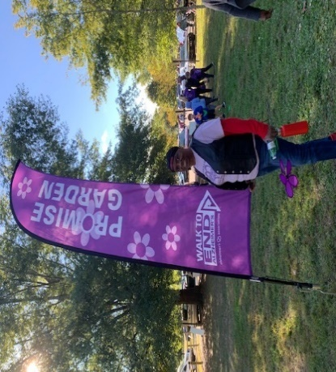
Linda Rollins stood tall “You may forget, but you will never be forgotten.”
in support of the Walk to
End Alzheimer’s.

Family Weekend was held at the Virginia Commonwealth University (VCU) where Ariana Mickels is now an Upperclassman. VCU Family Programs invited parents, families, and loved ones to join in for Family Weekend which was held on October 7-9. Family Weekend is an opportunity to come together to connect, have fun, become familiar with VCU, and explore the Richmond Community!
The Mickels family joined in on the event! Family is everything! From left to right siblings: Mikayla, Michael (Mikey) Jr., Ariana, Aaliyah and Alyssa!

We extend a very warm heartfelt congratulations to our
Rhonda Washington in completing all prescribed
requirements to obtain her Child Development
Associate (CDA) certification. Rhonda has been
doing Family Home Child Care for seventeen years.
Rhonda underwent a volume of training classes and
later went on to take the test and the rest is history!

The Youth Ministry hosted their last event for the year; the Ugly Sweater Contest.

. . . and the winner was Deacon
Aaron Mickels who received a $25.00
gift card from Target! Keep shining
for Jesus!
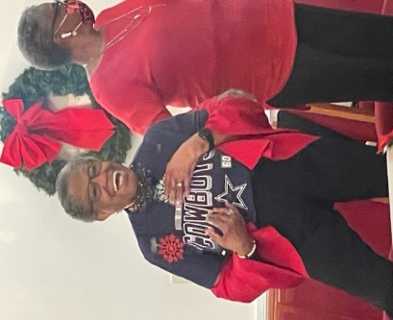

Marissa “Rissa” Morton presented her ugly sweater. Good job Rissa!
All the Washington Commanders loved
the “ugly” Dallas Cowboys sweater
Evelyn Montague proudly wore.

CHURCH NEWS AND COMMUNITY EVENTS

Second New Hope

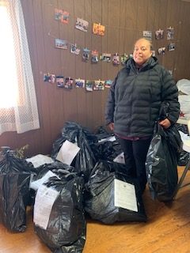
Many thanks to those who participated in the Christmas Hope gift giving project in align with the Spotsylvania Social Services. We were able to brighten the lives of 24 individuals; seniors, children and disabled! Thanks to those who donated wrapping paper and bows as well. It all matters!

Melissa Coleman helped with the collecting of the Christmas gift bags.

Pastor Hilliard, Linda Rollins and Lewis “Dr. Luke” Luco” Rollins assisted with turning in the Christmas gift bags to Social Services.
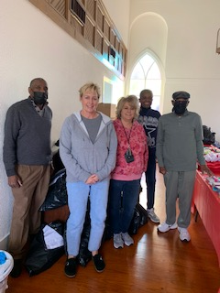
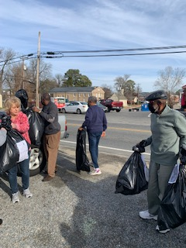

The Youth ministry thanked each person who particiapted in the COATS FOR KIDS project sponosored by the Spotsylvania Social Services. We collected over 25 coats of all sizes and colors for boys and girls!
“He who is gracious and lends a hand to the poor lends to the Lord, and the Lord will repay him for his good deed.” Proverbs 19:17 AMP

The Sundy School ministry hosts a Drive Thru Food Drive each fourth Saturday of the month from 10:00 am to 12:00 noon on the church grounds. Monetary donations are also solicited. All proceeds are given directly to the Fredericksburg Area Food Bank.

THANK YOU FOR YOUR DONATION!

